**X10 Login Reboot Script – Robot Framework**

1. Download the latest chromedriver: <https://chromedriver.chromium.org/downloads>
   1. Place the chomedriver in a folder along with the Login_Reboot.robot file
2. Download Visual Studio Code: <https://code.visualstudio.com/docs/?dv=osx>
   1. Visual Studio Code will make it easy to execute the script
3. Open the Login_Reboot.robot to make some changes:
   1. **${LOGIN URL} (Line 6):**
      1. Change ${LOGIN URL} to the URL of the device under test
      2. Make sure that the IP Address of the device is correct
   2. **Number Of Loops (Line 12):**
      1. Change the last number to dictate the number of loops the script will go through
      2. Do not change “0”



* 1. **Change Login Information (Line 13-14):**
     1. Change the username and password information after “Input Username” and “Input Password” for the script to be able to login to the device



1. Running the script:
   1. In the terminal in visual studio code, go to the directory/file where the Login_Reboot.robot file is located
   2. To execute the script enter either of the following:
      1. “robot Login_Reboot.robot” (to run a particular file)
      2. “robot .” (to run all tests – this is fine if there is only 1 .robot file within the folder)

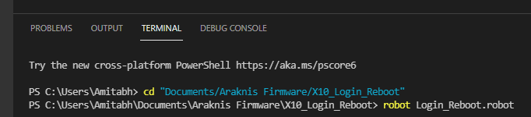

1. After running the script:
   1. After the script runs successfully, it should let you know in the terminal that the run has PASSED

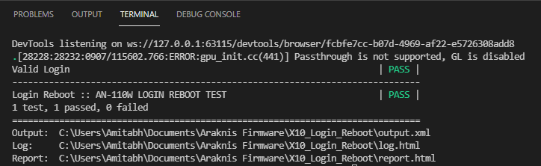

* 1. In the folder where the script was placed, there should be two HTML files named “log” and “report”. These will show details from the script after it ran. Feel free to look into these and expand the Test Execution Log to view additional details.

